PLANETARY ALIGNMENTS AND THE SOLAR CYCLE:
spaceweather.com

This week, Jupiter and Venus are on opposite sides of the sun. To some researchers, this geometry is more than a celestial coincidence. A small but persistent body of research suggests that planetary alignments help regulate solar activity.
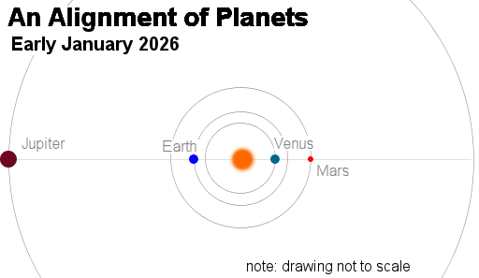
"A decade ago, I set out to to find a viable mechanism by which the solar cycle could be synchronised by tidal forces of the planets," says Frank Stefani, a physicist at the HDZR national research center in Germany. "These forces are known to be very small, yet we have developed a model that shows remarkable agreement with observed solar activity."
This is a controversial topic. Some researchers, like Stefani, have focused their careers on it, while others are vehemently opposed. The idea refuses to go away because Jupiter, Venus, and Earth form repeating alignment patterns with a characteristic period near 11 years, similar to the average length of the sunspot cycle. Coincidence--or something more?
Mainstream solar physics holds that the tides of Venus and Jupiter are too weak to affect solar activity. Jupiter's tides on Earth are a million times weaker than the Moon's tides, and Venus's tides are even weaker than Jupiter's. How could these absurdly small forces affect the sun?
A 2019 study led by Stephani suggested a way: The sun's inner magnetic dynamo is exquisitely sensitive to external perturbations ("parametric resonances"). Regular "taps" from planetary tides could nudge the dynamo into an 11-year pattern like a metronome keeping a piano player on time.
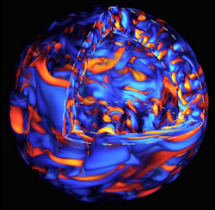
Critics note that convective noise in the sun's interior (pictured right) dwarfs tidal stresses. Yet the coincidences are hard to ignore.
Stefani’s more recent work focuses on magneto-Rossby waves in the solar dynamo. "Our latest model shows that the natural periods of these waves fit amazingly well to the two-planet spring tides of Venus, Earth, and Jupiter: 118 days for Venus-Jupiter, 199 days for Earth-Jupiter, and 292 days for Venus-Earth."
These spring tides don't *cause* the solar cycle, asserts Stefani. They help synchronize it. Tidal beat-periods match several well-known cycles of solar activity including the famous Schwabe cycle of 11 years, a Quasi-Biennial Oscillation (QBO) of 1.7-years, and the Suess-de Vries cycle of 193 years (plus two Gleissberg cycles at 90 and 58 years).
Again, critics have a counterargument: With so many cycles and harmonics to play with, you can always find a match. Indeed, this may be true.
But Stefani has a prediction: "The present alignment is happening only 40 to 60 days before the expected peak of a Quasi-Biennial Oscillation. If the alignment excites magneto-Roseby waves as our model predicts, we might expect a higher probability of strong solar activity 40 to 60 days from now."
Link: https://www.spaceweather.com/ vom 7. Januar 2025

